March 4, 2010

Senator Elizabeth Schneider
Representative Nancy Smith
Co-Chairs
Joint Standing Committee on Business, Research and Economic Development
Maine Legislature
3 State House Station
Augusta, Maine 04333

Dear Senator Schneider and Representative Smith:

I am writing on behalf of the Association of National Advertisers (ANA) to express our strong opposition to the “Act to Prevent Predatory Marketing Practices Against Minors,” Public Law 2009, Chapter 230, as well as the new bill introduced this year to address the serious legal problems with that law: LD 1677, the “Act to Protect Minors from Pharmaceutical Marketing Practices.”

We commend the Joint Standing Committee on Judiciary for closely examining the serious legal issues raised by Chapter 230. While we share the original goals to protect sensitive medical information about minors in the online environment, Chapter 230 is seriously overbroad. We agree with the Maine Independent Colleges Association, the Maine Press Association, NetChoice and Reed Elsevier that Chapter 230 violates the First Amendment and the dormant commerce clause of the United States Constitution and is preempted by the federal Children’s Online Privacy Protection Act (COPPA). We appreciate the fact that LD 1677 would repeal Chapter 230 and replace it with a new regulatory regime that is more narrowly drafted than Chapter 230. However, we continue to believe that LD 1677 raises the same legal and constitutional concerns as last year’s legislation. Therefore, we urge the members of the Maine Legislature to simply repeal Chapter 230.

Founded in 1910, the ANA (Association of National Advertisers) leads the marketing community by providing its members with insights, collaboration, and advocacy. ANA’s membership includes 350+ companies with 9,000 brands that collectively spend over $250 billion in marketing communications and advertising. The ANA strives to communicate marketing best practices, lead industry initiatives, influence industry practices, manage industry affairs, and advance, promote, and protect all advertisers and marketers. Many of our members conduct substantial business operations in the State of Maine. For more information, visit http://www.ana.net/.

Under Chapter 230, an entity may not knowingly collect, receive or use personal information or health-related information from a minor without first obtaining verifiable parental consent. Even with verifiable parental consent, the law bans the knowing or unknowing use of any personal information or health-related information to market a product or service to a minor under the age of 18 or to encourage a minor under age 18 to take an action relating to a product. Chapter 230 provides for a private right of action through which penalties of $250 or actual damages, whichever is greater, are recoverable per violation. The law provides no relief for companies in the event that a minor in Maine lies about his or her age to request marketing materials.

Chapter 230 is Preempted by COPPA

We agree that the privacy of children must be protected in the online environment. We worked closely with Congress and the Federal Trade Commission (FTC) to pass the Children’s Online Privacy Protection Act (COPPA). Due to the global nature of the Internet, Congress determined that a national uniform standard is needed to protect children. Thus, to avoid a patchwork of inconsistent regulation, section 1303(d) of COPPA preempts state or local government laws that are inconsistent with COPPA. Chapter 230 is clearly inconsistent with COPPA in several ways: it covers all collection of information from minors, both offline and online, while COPPA applies only to online activities; it covers collection of information from all persons under age 18, while COPPA applies only to persons under age 13. We believe that Chapter 230 is preempted by COPPA.

Chapter 230 Imposes Excessive Burdens on Interstate Commerce

By seeking to regulate conduct that occurs outside of Maine, Chapter 230 violates the dormant commerce clause. The law would force out-of-state websites to treat Maine residents differently, or to treat all Internet users as if they were residents of Maine. Under Pike v. Church, 397 U.S.137 (1970), if the burden imposed by a state law is clearly excessive in relation to the putative local benefit, and if the local interest can be promoted by other regulations that have a lesser impact on interstate activities, the courts may strike down a state law that burdens interstate commerce. Chapter 230 imposes an excessive burden on interstate commerce. In addition, the interest of protecting children’s privacy online is already addressed by COPPA, a uniform federal law.

Chapter 230 Violates the First Amendment

Finally, we believe Chapter 230 violates the First Amendment because it imposes content-based restrictions on speech and will restrict the ability of minors in Maine to receive valuable information about a broad range of issues, products and services.

The U.S. Supreme Court has made it clear that truthful, nondeceptive commercial speech cannot be banned or restricted unless the restriction “directly and materially advances” a “substantial governmental interest” and is “narrowly tailored” to “reasonably fit” that interest. See Central Hudson Gas and Electric Corporation v. Public Service Commission of New York, 447 U.S. 557 (1980).

Chapter 230 is overbroad and does not directly advance the government’s interest in protecting children’s privacy online. The law restricts any collection of information, whether online or offline. Further, there are numerous technological tools that parents can use to prevent their children from providing personal or health-related information online. Thus, Chapter 230 is more restrictive of speech than is necessary.

Conclusion

We appreciate the fact that the Attorney General has acknowledged serious concerns with the substantial over breadth of Chapter 230 and has committed not to enforce it. However, the law creates a private right of action for statutory damages, which continues to have a chilling impact on protected speech. We acknowledge that LD 1677 is much more narrowly drafted than Chapter 230. Nevertheless, we believe that LD 1677 raises the same legal and constitutional issues as Chapter 230.

For all of the reasons discussed above, we urge you to simply repeal Chapter 230.

Thank you for your consideration of our views.

Sincerely,
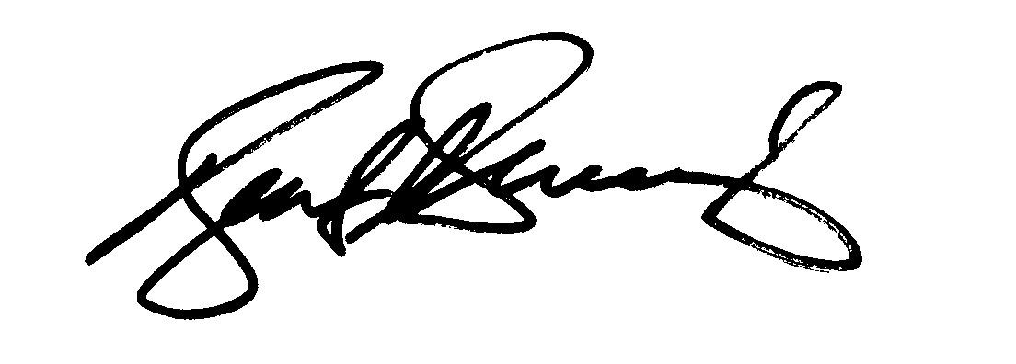
Keith A. Scarborough
Senior Vice President, Government Relations
Association of National Advertisers
1120 20th Street, NW, Suite 520-South
Washington, DC 20036
(202) 296-1883
kscarborough@ana.net

